BRAINWARE UNIVERSITY
STUDENT ATTENDANCE AND RESTAURANT ORDER MANAGEMENT SYSTEM (WEEK 9)

1. Basic Information
Programs Covered: | Program 1: Student Attendance Management System  Program 2: Restaurant Order Management System
Name(s) of Student(s): | Soumyadwip Das (BWU/BTS/25/169)  Ankita Paul (BWU/BTS/25/180)  Sonia Naskar (BWU/BTS/25/195)  Joyeta Mondal (BWU/BTS/25/214)  Sayantan Bharati (BWU/BTS/25/503)
Programme & Semester: | B.Tech CSE & 3rd Semester
Course Name & Code: | Python Programming Lab (BES09013)
Name of the Guide/Supervisor: | MR. PRANAB GHARAI & MR. INDRANIL DAS
Project Date | 11/09/2026



2. Introduction and Background
Week 9 covers two menu-driven, terminal-based record-management tools: a Student Attendance Management System for recording daily presence/absence and computing attendance percentages, and a Restaurant Order Management System for taking orders against a fixed menu and generating a billed receipt. Both programs keep core data-handling logic in dedicated functions separate from the input/output (menu) handling, and both use in-memory Python dictionaries as their data store.

3. Objectives of the Project (Week 9)
Program 1 - Student Attendance Management System
- Add and store student records (roll, name)
- Record daily attendance status (Present/Absent) per student
- View attendance by student or by date
- Calculate attendance percentage and flag students below a threshold
Program 2 - Restaurant Order Management System
- Display a fixed restaurant menu with prices
- Take an order with multiple items and quantities
- Calculate the bill with an optional discount
- Generate a formatted receipt

4. Problem Statement / Driving Question
Program 1: How can daily attendance be recorded and summarised so low-attendance students can be identified quickly?
Program 2: How can orders against a shared menu be totalled accurately, with discounts applied correctly, and turned into a receipt?

5. Methodology (Week 9 Activities)
Program 1 - Student Attendance Management System
- Modelled each student as a dictionary entry keyed by roll number, holding a nested date-to-status dictionary
- Built core functions (add_attendance_student, record_attendance_data) with no I/O
- Built get_attendance_percentage and get_low_attendance to summarise records
- Added a parse_date helper to validate YYYY-MM-DD input
- Built UI handler functions in a menu loop that call the core functions and print boxed results
Program 2 - Restaurant Order Management System
- Modelled a fixed menu dictionary and a separate current-order dictionary
- Built core functions (add_to_order, compute_bill, build_receipt_lines) with no I/O
- Built UI handlers for displaying the menu, taking an order, and billing
- Supported an optional percentage discount applied to the subtotal
- Tested order-taking, bill calculation with and without discount, and receipt generation

6. Expected Outcomes / Deliverables (Week 9)
- Working Student Attendance Management System with percentage tracking
- Working Restaurant Order Management System with billed receipts
- Clear separation of core logic and UI code in both programs
- Accurate attendance percentage and low-attendance detection
- Accurate bill totals with correct discount handling

7. Core Logic
Program 1 - Student Attendance Management System
def add_attendance_student(roll, name):
if roll in attendance_students:
return False
attendance_students[roll] = {'name': name, 'attendance': {}}
return True

def record_attendance_data(roll, date_obj, status):
if roll not in attendance_students: return False
if status not in ('P', 'A'): return False
attendance_students[roll]['attendance'][date_obj] = status
return True

def get_attendance_percentage(roll):
data = attendance_students[roll]['attendance']
if not data: return 0.0
present = sum(1 for s in data.values() if s == 'P')
return (present / len(data)) * 100

def get_low_attendance(threshold):
result = []
for roll, data in attendance_students.items():
att = data['attendance']
pct = 0.0 if not att else (sum(1 for s in att.values() if s == 'P') / len(att)) * 100
if pct < threshold:
result.append((data['name'], roll, pct))
return result

Program 2 - Restaurant Order Management System
def add_to_order(item, qty):
if item not in menu: return False
if qty is None or qty <= 0: return False
current_order[item] = current_order.get(item, 0) + qty
return True

def compute_bill(discount_rate=0.0):
if not current_order: return 0.0, 0.0, 0.0
subtotal = sum(menu[item] * qty for item, qty in current_order.items())
discount = subtotal * discount_rate
total = subtotal - discount
return subtotal, discount, total

def build_receipt_lines(subtotal, discount, total, discount_rate):
lines = ["RECEIPT:", "", f" Date: {datetime.datetime.now():%Y-%m-%d %H:%M:%S}"]
for item, qty in current_order.items():
price = menu[item]
lines.append(f" {item:<12}{qty:<6}${price:<9.2f}${price*qty:.2f}")
lines.append(f" Subtotal: ${subtotal:.2f}")
if discount > 0:
lines.append(f" Discount ({discount_rate*100:.0f}%): -${discount:.2f}")
lines.append(f" Total: ${total:.2f}")
return lines

8. Output Screenshot
Program 1 - Student Attendance Management System
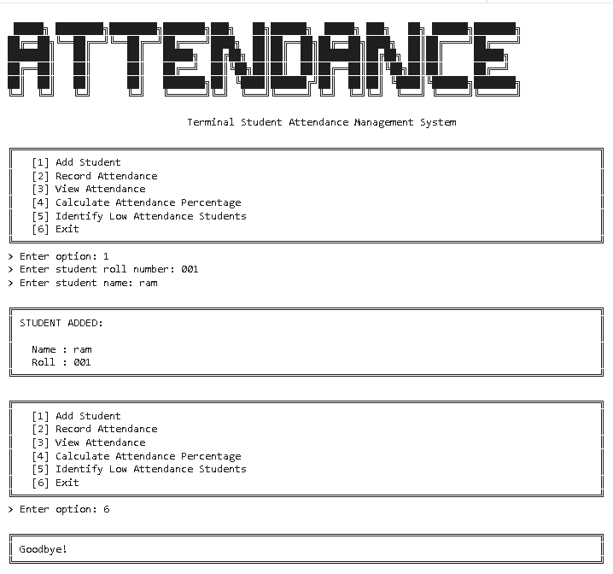

Program 2 - Restaurant Order Management System
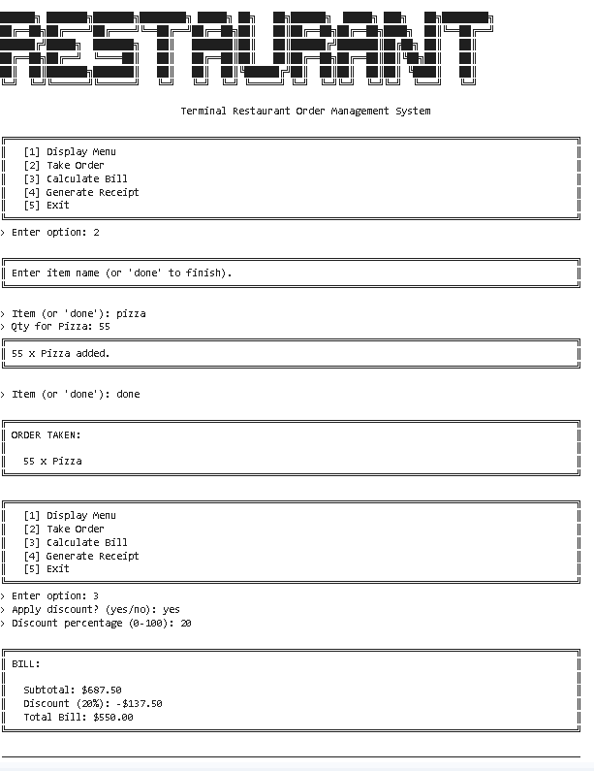

9. Tools & Technologies Used
Tool / Technology | Purpose
Python 3.x | Core language for both console systems
Python Dictionaries | In-memory storage for students, attendance records, menu, and orders
Core/UI Separation | Business logic functions kept separate from input/print handlers
datetime module | Date parsing/validation and receipt timestamps
String Formatting (f-strings) | Aligned tabular display of attendance and receipts

10. References
- Python Official Documentation: https://docs.python.org/3/
- Python datetime Module Guide: https://docs.python.org/3/library/datetime.html
- Brainware University – Python Course Guidelines

11. Signatures
Signature of Student(s): Date of Submission:

Signature of Guide/Supervisor:

